**Format and Mount an EBS Volume**

* **Attaching an existing EBS volume**
* Select an existing volume and click on Attach Volume
* Select the instance

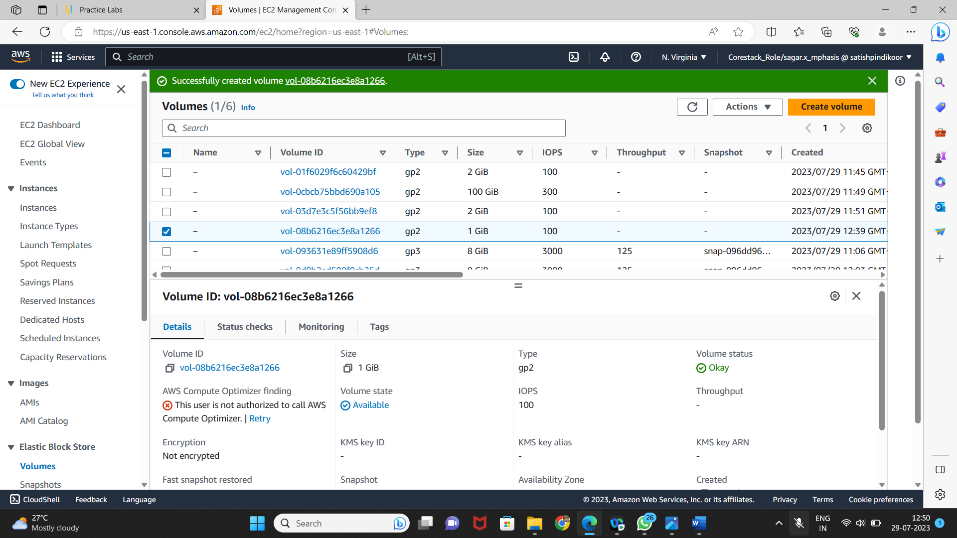

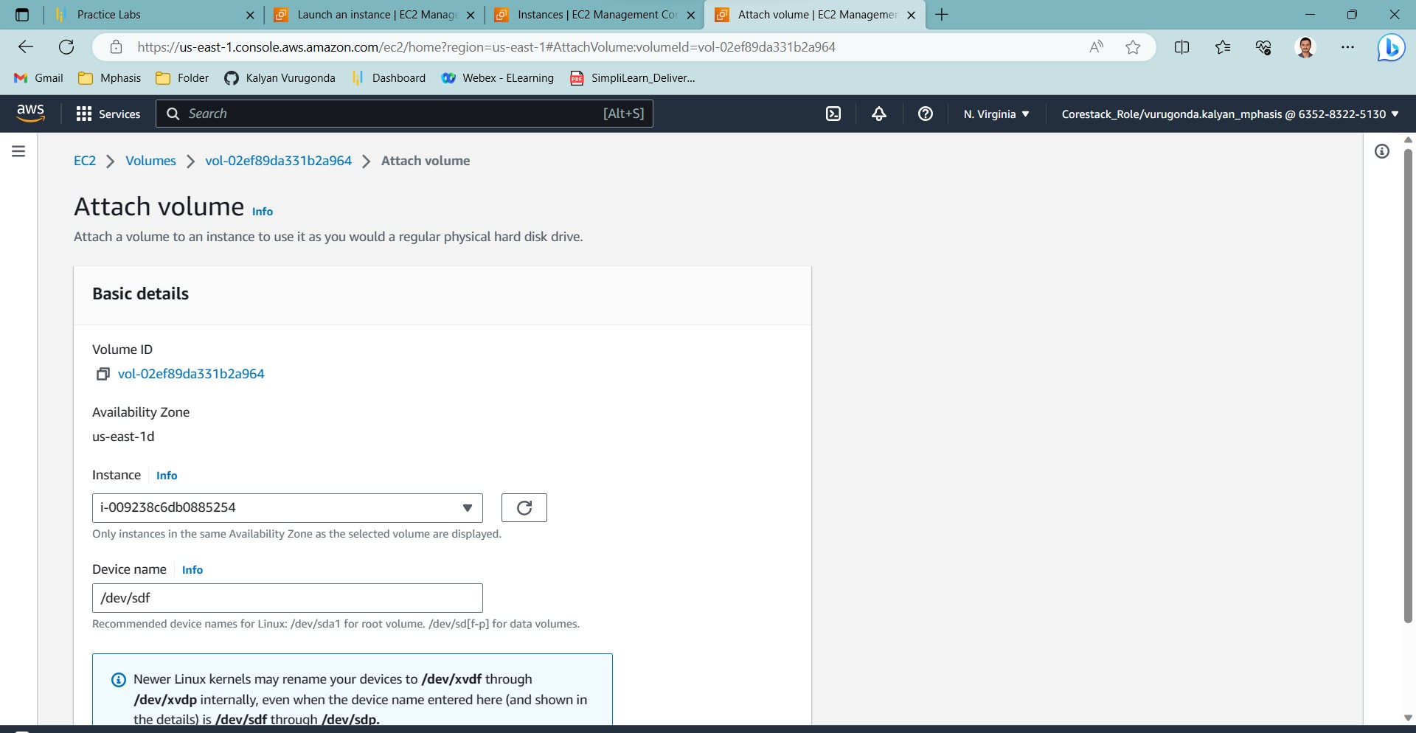

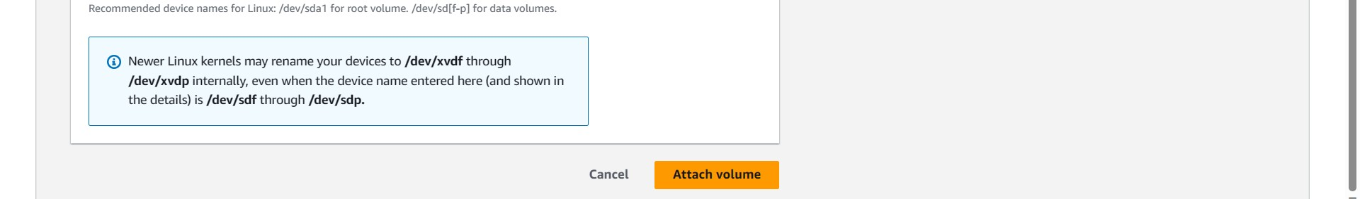

* **Mounting the EBS volume**
* Login to your EC2 instance and list the available disks using the following command:

# **ldblk**

* Use the following command to check if the volume has any data:

**sudo file -s /dev/xvdf**

* Use the following command to format the volume to ext4 filesystem:

**sudo mkfs -t ext4 /dev/xvdf**

* Use the following command to create a directory to mount the volume:

**sudo mkdir /newvolume**

* Use the following command to mount the volume:

**sudo mount /dev/xvdf /newvolume/**

* Check the disk space using the following command:

**/newvolume**

**df -h .**

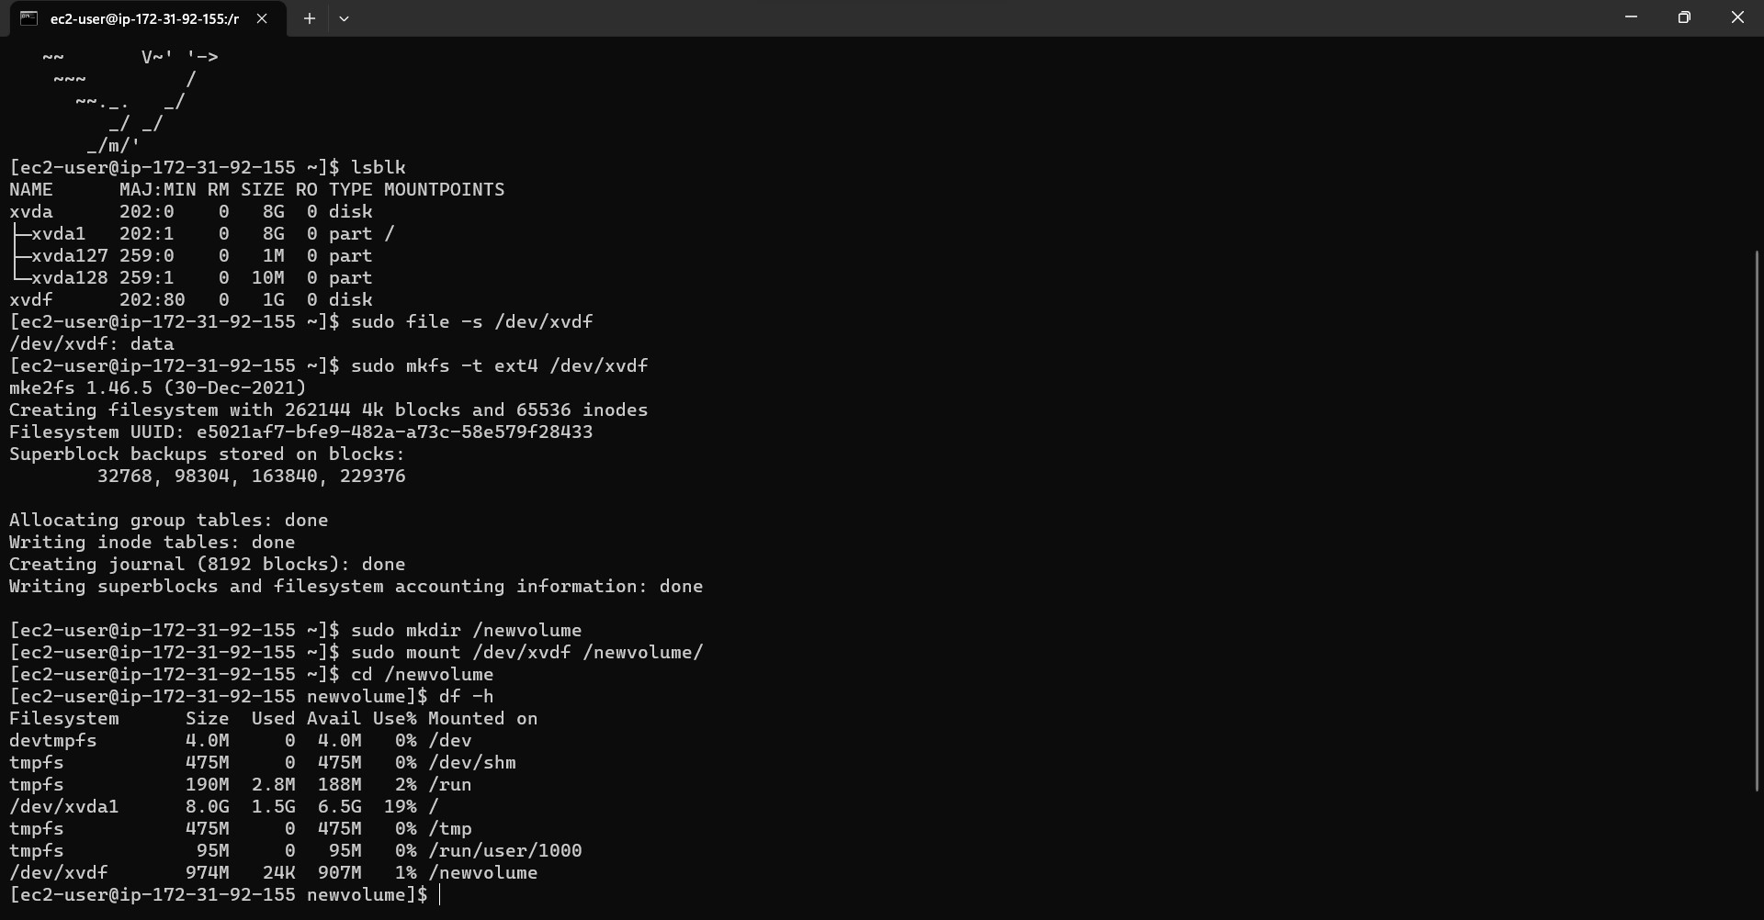

* ✓ **Unmounting the EBS volume**
* Use the following command to unmount the volume: umount /dev/xvdf